**Simple Network Simulation**

1. **Project Set up**

**Location:**

*/home/013/g/gx/gxa150630/CS4390/*

**UTD Hosts:**

1. cs1.utdallas.edu - Node 0
2. net30.utdallas.edu – Node 1
3. net31.utdallas.edu – Node 2
4. net32.utdallas.edu – Node 3
5. net33.utdallas.edu – Node 4
6. net34.utdallas.edu – Node 5
7. net35.utdallas.edu – Node 6

**Java Files:**

1. Node.java
2. MyHomeNetwork.java
3. NetworkLayer.java
4. TransportLayer.java
5. DataLinkLayer.java

**Main Class:**

Node.java

**Output files:**

1. From0to1.txt
2. From0to2.txt
3. from0to3.txt
4. From1to0.txt
5. From1to2.txt
6. from2to0.txt
7. from2to1.txt

**Key Generation:(http://www.linuxproblem.org/art_9.html)**

ssh-keygen -t rsa

ssh gxa150630@net31.utdallas.edu mkdir -p .ssh

cat .ssh/gxa150630.pub | ssh gxa150630@net30.utdallas.edu 'cat >> .ssh/authorized_keys'

cat .ssh/gxa150630.pub | ssh gxa150630@net30.utdallas.edu 'cat >> .ssh/authorized_keys2'

chmod 700 .ssh

chmod 640 .ssh/authorized_keys

**VPN setup**

<https://www.utdallas.edu/oit/vpn/>

<https://www.utdallas.edu/oit/netid/self-service/>

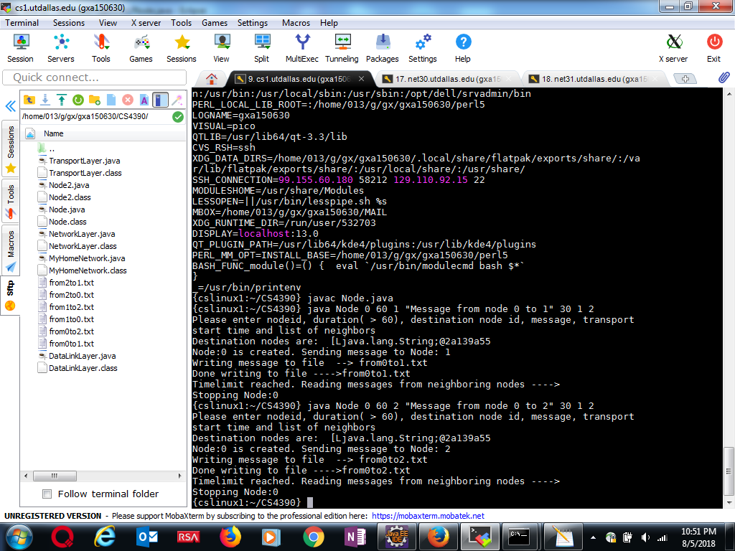

1. **Scenario#1: Two nodes Connected by a link**

**Commands to run**

*cd /home/013/g/gx/gxa150630/CS4390/*

1. ***java Node 0 60 1 "Message from node 0 to 1" 30 1 2***

*this will send message and write to file “from0to1”*

*{cslinux1:~/CS4390} java Node 0 60 1 "Message from node 0 to 1" 30 1 2*

*Please enter nodeid, duration( > 60), destination node id, message, transport start time and list of neighbors*

*Destination nodes are: [Ljava.lang.String;@2a139a55*

*Node:0 is created. Sending message to Node: 1*

*Writing message to file --> from0to1.txt*

*Done writing to file ---->from0to1.txt*

*Timelimit reached. Reading messages from neighboring nodes ---->*

1. ***java Node 1 60 0 "Message from node 1 to 2" 30 0 2***

*this will send message and write to file “from1to0”*

**{***net30:~/CS4390} java Node 1 60 0 "Message from node 1 to 0" 30 0 2*

*Please enter nodeid, duration( > 60), destination node id, message, transport start time and list of neighbors*

*Destination nodes are: [Ljava.lang.String;@6d06d69c*

*Node:1 is created. Sending message to Node: 0*

*Writing message to file --> from1to0.txt*

*Done writing to file ---->from1to0.txt*

*Timelimit reached. Reading messages from neighboring nodes ---->*

1. **Scenario#2: Three Nodes Connected as a cycle ( Scenario1 + 3rd node)**
2. **{cslinux1:~/CS4390} java Node 0 60 2 "Message from node 0 to 2" 30 1 2**

*Please enter nodeid, duration( > 60), destination node id, message, transport start time and list of neighbors*

*Destination nodes are: [Ljava.lang.String;@2a139a55*

*Node:0 is created. Sending message to Node: 2*

*Writing message to file --> from0to2.txt*

*Done writing to file ---->from0to2.txt*

*Timelimit reached. Reading messages from neighboring nodes ---->*

*Stopping Node:0*

1. **{net30:~/CS4390} java Node 1 60 2 "Message from node 1 to 2" 30 0 2**

*Please enter nodeid, duration( > 60), destination node id, message, transport start time and list of neighbors*

*Destination nodes are: [Ljava.lang.String;@6d06d69c*

*Node:1 is created. Sending message to Node: 2*

*Writing message to file --> from1to2.txt*

*Done writing to file ---->from1to2.txt*

*Timelimit reached. Reading messages from neighboring nodes ---->*

1. **{net31:~/CS4390} java Node 2 60 0 "Message from node 2 to 0" 30 0 1**

*Please enter nodeid, duration( > 60), destination node id, message, transport start time and list of neighbors*

*Destination nodes are: [Ljava.lang.String;@6d06d69c*

*Node:2 is created. Sending message to Node: 0*

*Writing message to file --> from2to0.txt*

*Done writing to file ---->from2to0.txt*

*Timelimit reached. Reading messages from neighboring nodes ---->*

*Stopping Node:2*

1. **{net31:~/CS4390} java Node 2 60 1 "Message from node 2 to 1" 30 0 1**

*Please enter nodeid, duration( > 60), destination node id, message, transport start time and list of neighbors*

*Destination nodes are: [Ljava.lang.String;@6d06d69c*

*Node:2 is created. Sending message to Node: 1*

*Writing message to file --> from2to1.txt*

*Done writing to file ---->from2to1.txt*

*Timelimit reached. Reading messages from neighboring nodes ---->*

1. **Scenario#3: Three Senders Same Receiver**

**Messages:**

java Node 0 60 0 "Setting up Scenario#3" 30 1 2 3 4

java Node 4 60 4 "Setting up Scenario#3" 30 0

java Node 1 60 4 "Message from 2 to 4" 30 0

java Node 2 60 4 "Message from 2 to 4" 30 0

java Node 3 60 4 "Message from 3 to 4" 30 0

**{net32:~/CS4390} java Node 0 60 0 "Setting up Scenario#3" 30 1 2 3 4**

*Please enter nodeid, duration( > 60), destination node id, message, transport start time and list of neighbors*

*Destination nodes are: [Ljava.lang.String;@6d06d69c*

*Node:0 is created. Sending message to Node: 0*

*Writing message to file --> from0to0.txt*

*Done writing to file ---->from0to0.txt*

*Timelimit reached. Reading messages from neighboring nodes ---->*

*Stopping Node:0*

***{net33:~/CS4390} java Node 4 60 4 "Setting up Scenario#3" 30 0***

*Please enter nodeid, duration( > 60), destination node id, message, transport start time and list of neighbors*

*Destination nodes are: [Ljava.lang.String;@6d06d69c*

*Node:4 is created. Sending message to Node: 4*

*Writing message to file --> from4to4.txt*

*Done writing to file ---->from4to4.txt*

*Timelimit reached. Reading messages from neighboring nodes ---->*

**{net30:~/CS4390} java Node 1 60 4 "Message from 1 to 4" 30 0**

*Please enter nodeid, duration( > 60), destination node id, message, transport start time and list of neighbors*

*Destination nodes are: [Ljava.lang.String;@6d06d69c*

*Node:1 is created. Sending message to Node: 4*

*Writing message to file --> from1to4.txt*

*Done writing to file ---->from1to4.txt*

**{net31:~/CS4390} java Node 2 60 4 "Message from 2 to 4" 30 0**

*Please enter nodeid, duration( > 60), destination node id, message, transport start time and list of neighbors*

*Destination nodes are: [Ljava.lang.String;@6d06d69c*

*Node:2 is created. Sending message to Node: 4*

*Writing message to file --> from2to4.txt*

*Done writing to file ---->from2to4.txt*

*Timelimit reached. Reading messages from neighboring nodes ---->*

**{net32:~/CS4390} java Node 3 60 4 "Message from 3 to 4" 30 0**

*Please enter nodeid, duration( > 60), destination node id, message, transport start time and list of neighbors*

*Destination nodes are: [Ljava.lang.String;@6d06d69c*

*Node:3 is created. Sending message to Node: 4*

*Writing message to file --> from3to4.txt*

*Done writing to file ---->from3to4.txt*

*Timelimit reached. Reading messages from neighboring nodes ---->*

*Stopping Node:3*

